Encouraging Vocalizations
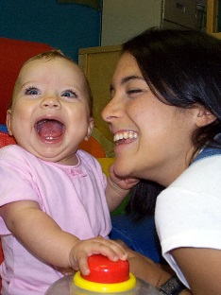
The goal of these activities is not exact imitation or communication, but rather increasing the child’s vocalizations. Eventually, we hope to get the child to use vocalizations to request an activity or continuation of an activity.

Pairing Vocalizations with Actions
- Begin by engaging in games, activities and motor play that the child enjoys (swinging, building blocks, bouncing, tickling, banging, etc.)

- Pair vocalizations with actions such as “ba-ba” while banging something on the table or bouncing the child on a ball. Say “mmm” when the child is eating she likes, “boom-boom” while hitting a drum, or “uh-oh” when blocks fall over. Say “pat-pat-pat” while patting the play-doh. Try “wheeee” while pushing the child on a swing or swing her in a blanket. First, try sounds that are within a child’s repertoire or sounds that are easy to produce such as “ba,” “ma,” “pa.” Try fun sounds such as fake sneezing while saying “aaachoo,” putting the child’s hands on your face while blowing raspberries, or saying “Night-night” lying down and fake snoring.

- Don’t require sounds or tell the child to say anything. Once the child knows the game, pause occasionally to give the child a chance to vocalize. The most important thing is to make the interaction fun while pairing sounds with actions. Over time the child may begin to make more sounds.
Vocal Contingency
- Once the child is making sounds, try waiting for the sound to continue a favorite activity. If he likes tickle games, tickle and pair with “tickle tickle tickle.” Stop and wait for a sign from the child to continue. It doesn’t have to be a sound at first, any sign will do – looking, reaching for your hand, smiling, etc.

- The child may begin to make sounds to continue the game. It may be a squeal or a sound like “uh”. Accept any form of communication to continue the game, focusing on the interaction and making it fun for all.

- If the child attempts to make a sound, model it again and see if you can get back and forth turn-taking going. Strings of sounds between you and the child are a huge milestone.

- If the same sound is paired with a favorite activity, over time, the child may begin to use the sound to request the activity or to request continuation of the activity.

