Creating Routines within Routines

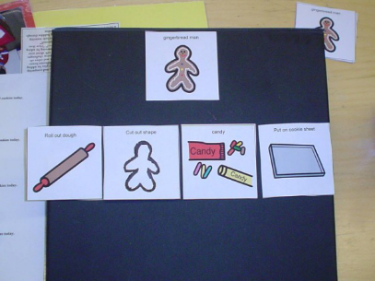
To promote learning, establish a routine and keep it as consistent as possible. Every routine or activity should have a clear, beginning, middle, and end and kids should have a role in marking them. Develop a structure for the routine and be consistent. This helps kids to feel safe and comfortable and able to participate. Take time to teach the routine. Practice and provide repetition to build understanding and skills. As kids know what to expect, they will participate.
  - What does the student have to say or do to BEGIN the activity?
  - What does the student to have to say or do to CONTINUE the activity?
  - What does the student have to say or do to END the activity?
- Once kids know what to expect and how to participate gradually introduce changes, expect more, etc.
- Introduce the activity – give kids a role if possible.
- Making decisions, having a role in the routine, and communicating preferences are very important skills. It begins by teaching students to make a choice. Offering choices also increases engagement by letting a child choose the activity that he/she wants. Offer two choices. Keep it simple. Once students can easily decide between two options in a variety of routines, you may introduce a third choice. This method will help children think of various options and make decisions.
- Choices can be built into almost any part of the daily activities and routines.
- Once you have a clear beginning, we build the middle of the routine.
- INTERESTING/FUN/ENGAGING
- PREDICTABLE SEQUENCE – Repetitive
- OPPORTUNITIES FOR PARTICIPATION – Learn by doing – props/materials, take turns, point to pictures, etc.
- OPPORTUNITIES FOR COMMUNICATION –Arrange the environment
- The basics are really to engage the student.
- Use meaningful gestures, wait for them to attend to you,
- use language at their level and respond to their attempts naturally.

